Task 7

1. How to delete all the lines where the pattern is present using sed command?

Syntax : **sed ‘/pattern/d’ <filename>**

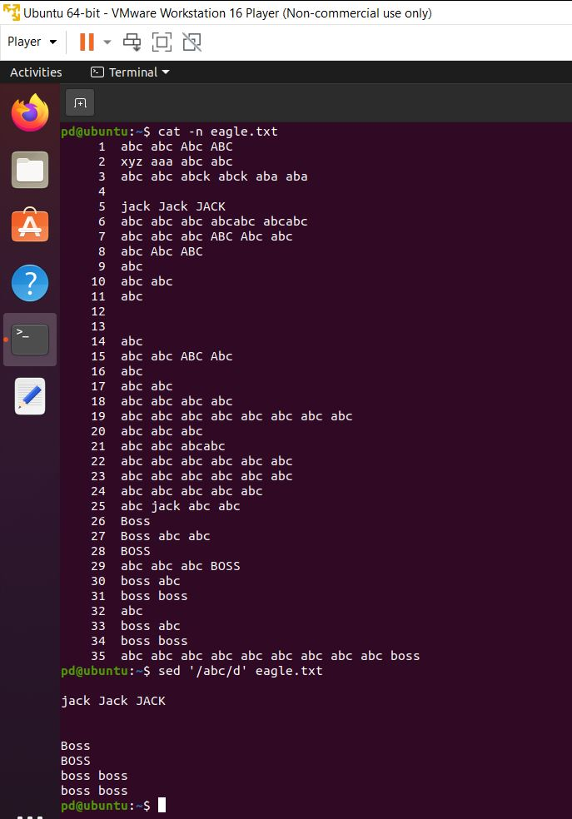

1. How to delete empty lines in a closed file?

Syntax **: sed ‘/^$/d’ <file name>**

1. ^: Matches the beginning of a line.
2. $: Matches the end of a line.
3. d: Deletes the line that matches the pattern (empty lines in this case).

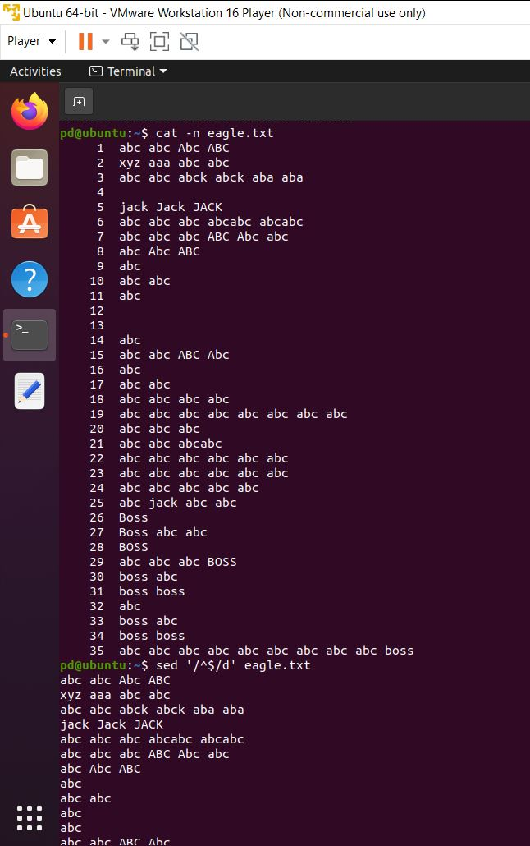

1. How to delete the characters in a forward direction in a opened file (vi editor)?

Sol: Press **x** to delete the character under the cursor.

1. How to delete the characters in a forward direction in a opened file (vi editor)?

Sol: Press (Shift +**X)** to delete the character under the cursor.